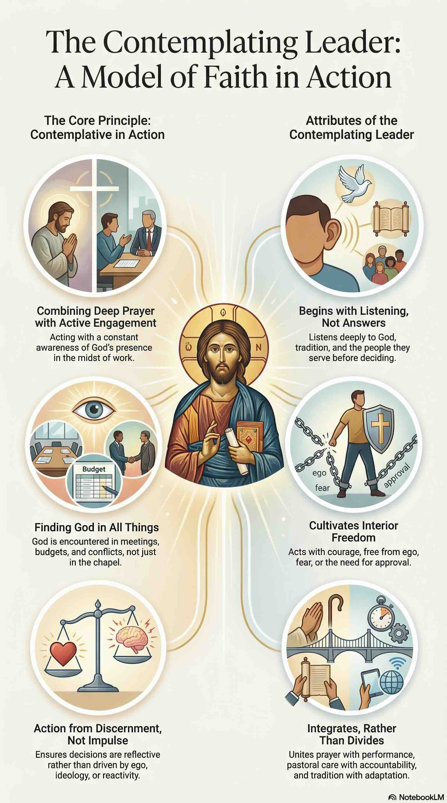
- The Contemplating Leader
“Contemplation does not mean withdrawal from the world, but immersion in it with God’s eyes.” Pedro Arrupe, SJ
The expression “contemplative in action” (from the Latin contemplativus in actione) originates in the Ignatian spiritual tradition and denotes a distinctive integration of prayerful awareness and active engagement. Although the phrase itself does not appear in the writings of St. Ignatius of Loyola, it was articulated and promoted by Jerónimo Nadal (1507–1580), one of Ignatius’ early companions. Nadal used the term to interpret Ignatius’ vision for the Society of Jesus, describing a way of life in which deep communion with God is maintained amid demanding apostolic work. Central to this vision is Ignatius’ belief that God can be encountered in every aspect of life. To be contemplative in action, therefore, is to live and act with an ongoing awareness of God’s presence.
A contemplating leader seeks to notice and interpret the movements of the Spirit in everyday responsibilities, decisions, and relationships. In addition to daily periods of stepping back from the world to pray, the contemplating leader also encounters God precisely in leadership, service, and work. Contemplation in action is not withdrawal or avoidance; it is a discipline that ensures leadership choices emerge from discernment and freedom rather than from habit, ideology, or self-interest.
Within faith-based organizations, leadership cannot be reduced to technique or administration alone. It is inherently spiritual, ethical, and relational. Leading as a contemplative in action means holding together attentiveness to God and accountability to mission, so that structures, decisions, and organizational culture are shaped by reflection rather than reaction. Such leaders begin not with ready-made solutions but with deep listening—to God, to the organization’s charism and tradition, to contemporary realities, and to the experience of those they serve. Decision-making is therefore prayerful and deliberate. The contemplating leader is open to growth and conversion. Far from undermining authority, this approach clarifies and strengthens it, enabling leaders to act with resolve while remaining grounded and accountable.
For the contemplating leader, God is encountered not only in the chapel but also in the practical and sometimes difficult realities of organizational life: meetings, governance, budgeting, conflict, policy development, structural change, and the responsible use of power. These everyday contexts become places of discernment and grace. Leadership decisions are assessed not solely by efficiency or outcomes, but by their alignment with gospel values, justice, and the organization’s founding story.
Contemplating leaders intentionally cultivate their interior freedom—freedom from ego, fear, status-seeking, and the need for approval. This inner disposition allows them to speak hard truths, address organizational decline, resist mission drift, and prioritize the common good over self-protection. Such freedom makes possible leadership marked by courage, compassion, and steadfastness, particularly in times of pressure or polarization.
Rather than accepting false dichotomies—such as prayer versus productivity, care versus accountability, or tradition versus change—the contemplating leader holds these elements together. Pastoral sensitivity is joined with clear expectations; spiritual depth is integrated with professional competence; fidelity to mission is balanced with responsiveness to new contexts.
Ultimately, the contemplating leader plays a formative role. The way he or she listens, discerns in common, decides, and exercises authority shapes how others understand God at work in organizational life. Through their leadership, they witness to the truth that action flows from faith, and that faith is deepened through action. To lead as a contemplative in action is to govern, decide, and serve from a sustained attentiveness to God, allowing prayer and practice to inform one another amid the real demands of mission, people, and power. Leadership becomes an ongoing spiritual discipline in which reflection and action are constantly shaping each other.

