- Leading an organization through transformative change
This contemplative exercise is based on an article by Ronald A. Heifetz and Marty Linsky, “A Survival Guide for Leaders,” which is summarized here. Leading an organization through a transformative change is inherently risky because it requires individuals to give up cherished habits, loyalties, and ways of thinking. This “adaptive change” differs from technical fixes because the solution is within the people themselves, who often resist the change by attacking the leader. To succeed, leaders must use strategies that address both external organizational threats and internal personal vulnerabilities.
Externally, leaders should “get on the balcony,” a contemplative exercise in which they step back to gain perspective while remaining active participants in the situation.
It is crucial to “court the uncommitted” by recognizing the pain that change causes and modeling the desired behavior themselves to build support. Effective leadership also involves “cooking the conflict,” which means keeping organizational stress within a “productive range of distress”—high enough to motivate action but low enough to prevent a complete breakdown. Additionally, leaders must “place the work where it belongs” by making the organization take responsibility for its problems rather than providing all the answers.
Internally, leaders must guard against their own “hungers,” especially the harmful desires for total control or constant approval, which can lead to self-deception and employee dependence.
To stay stable, leaders need to “anchor themselves” by finding a private space for reflection and a confidant who offers honest feedback. Importantly, they must separate their personal identity from their professional role, understanding that most attacks are aimed at the position rather than the person. Ultimately, although the risks are high, the rewards of making a meaningful impact and living a purposeful life make the leadership journey worthwhile.

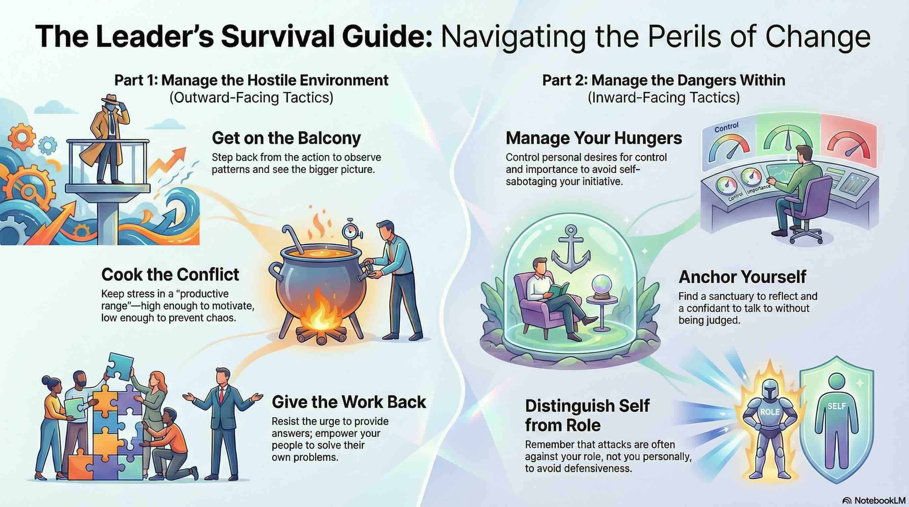

Scripture
“Above all else, guard your heart, for everything you do flows from it” (Proverbs 4:23).
This verse resonates with Heifetz and Linsky’s emphasis on anchoring yourself to ensure that your leadership remains purposeful and your “moral compass” stays calibrated.
What I ask God for
Grant me the grace to maintain a balcony perspective so that I may lead with wisdom and compassion even when the heat of conflict rises, and my personal role is under attack.
Questions to contemplate
- In your current leadership challenge, are you treating an “adaptive” problem with a “technical” fix, and what work must you do for your team for a sustainable solution?
- How can you better distinguish between your personal identity and your professional role to prevent personal attacks from undermining your stability?
- Where is your “safe harbor” or sanctuary, and have you prioritized it enough to renew your emotional resources amidst the stress of change?
Resource
Ronald A. Heifetz & Marty Linsky, “A Survival Guide for Leaders,” Harvard Business Review, June 2002.

