- Job crafting (shaping your leadership role)
Leaders typically excel at what they truly want to do. If you can use your God-given gifts and abilities in your role, you'll be more productive and effective in your mission. Some parts of your role will align more closely with your gifts and abilities, while others may not. If you focus on aspects that don't match your talents, you're likely to become stressed and exhausted.
That is not to say you can simply ignore parts of your role that don’t suit you. Some leaders create a leadership vacuum by skipping certain responsibilities and leaving others to pick up the slack. Such behavior is both irresponsible and unfair. It breeds resentment among team members who have to handle some of the leader’s duties in addition to their own.
It may be possible to shape your role (job craft) so that it better matches your abilities and strengths. You could, for example, delegate certain tasks to others in your organization who have the skills and strengths you lack. Naturally, the person should be fairly compensated, and their role description renegotiated. Alternatively, you could improve your skills in areas where you’re less proficient.
Gospel
Jesus called them together and said, ”You know that the rulers of the Gentiles lord it over them, and their high officials exercise authority over them. Not so with you. Instead, whoever wants to become great among you must be your servant, and whoever wants to be first must be your slave— just as the Son of Man did not come to be served, but to serve, and to give his life as a ransom for many” (Matthew 20:25-28).
What I ask God for
I pray for the insight to shape my role so that it aligns more with my capacities and strengths.
Questions to contemplate
- What am I good at as a leader?
- Where do I struggle as a leader?
- How could I delegate or upskill?
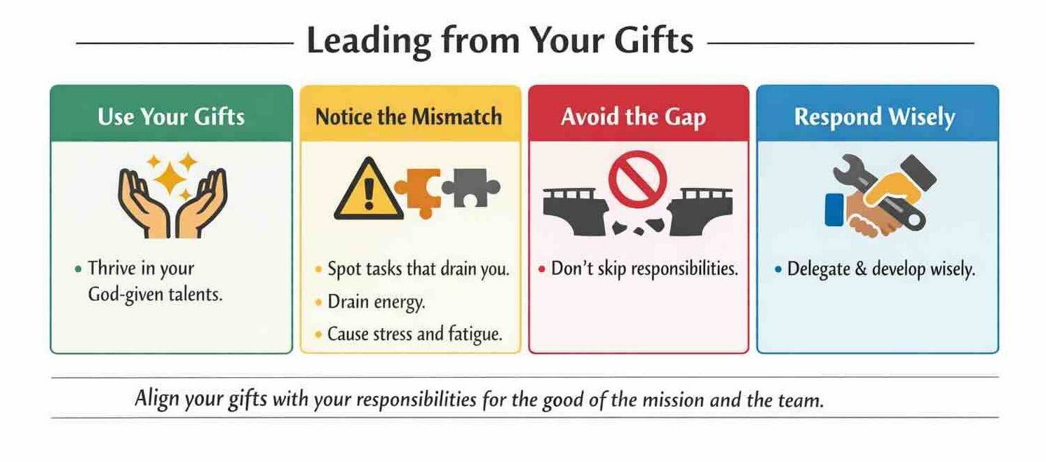
Resource
Catherine Moore. 2019. “What Is Job Crafting?” PositivePsychology.com

