- Hope Theory and Organizational Leadership
Hope Theory offers a rich and practical framework for organizational leadership, especially in contexts marked by uncertainty, change, or moral complexity. Rather than understanding hope as mere optimism or wishful thinking, psychologist C. R. Snyder defines hope as a dynamic cognitive–motivational process comprising three interrelated elements: (1) goals, (2) pathways thinking, and (3) agency. Together, these elements describe how individuals and groups envision a desired future and sustain the energy to move toward it.
Goals. In organizational leadership, goals provide direction and meaning. Hopeful leaders articulate clear, credible goals that are grounded in the organization’s purpose and values. These goals are neither abstract ideals nor rigid targets; they are compelling visions that help people see how their daily work contributes to a larger story. When goals are meaningful, they anchor commitment and orient decision-making.
Pathways thinking refers to the capacity to imagine multiple routes toward these goals. Leaders shaped by hope do not assume a single, linear strategy will suffice. Instead, they encourage adaptability, creativity, and shared problem-solving. When obstacles arise, hopeful leaders help others reframe setbacks as signals to find alternative paths rather than reasons to abandon the mission. This nurtures resilience and collective learning within the organization.
Agency. The third element, agency, concerns the motivational energy to initiate and sustain action. In leadership, agency is expressed through perseverance, courage, and confidence in the capacity to influence outcomes. Hopeful leaders model this energy and empower others, cultivating a shared sense that “we can find a way forward together.”
Snyder’s Hope Theory thus reframes leadership as the work of sustaining purposeful direction, imaginative flexibility, and resilient motivation. In doing so, it helps organizations resist cynicism and despair, enabling people to act with courage and meaning even in challenging circumstances.
Scripture
“May the God of hope fill you with all joy and peace in believing, so that you may abound in hope by the power of the Holy Spirit” (Romans 15:13).
What I ask God for
God of hope, strengthen our vision, widen our imagination, and renew our courage as we seek faithful paths toward the future you promise.
Questions to contemplate
- How clearly do our organizational goals express a hopeful and meaningful future rather than mere survival or efficiency?
- When obstacles arise, do I invite creative pathways, or do I become fixed on a single approach?
- How am I nurturing agency—both my own and that of others—so that hope becomes a shared and sustaining practice?
Resource
Colla, Rachel, Paige Williams, Lindsay G. Oades, and Jesus Camacho-Morles. 2022. “A New Hope for Positive Psychology: A Dynamic Systems Reconceptualization of Hope Theory.” Frontiers in Psychology 13.

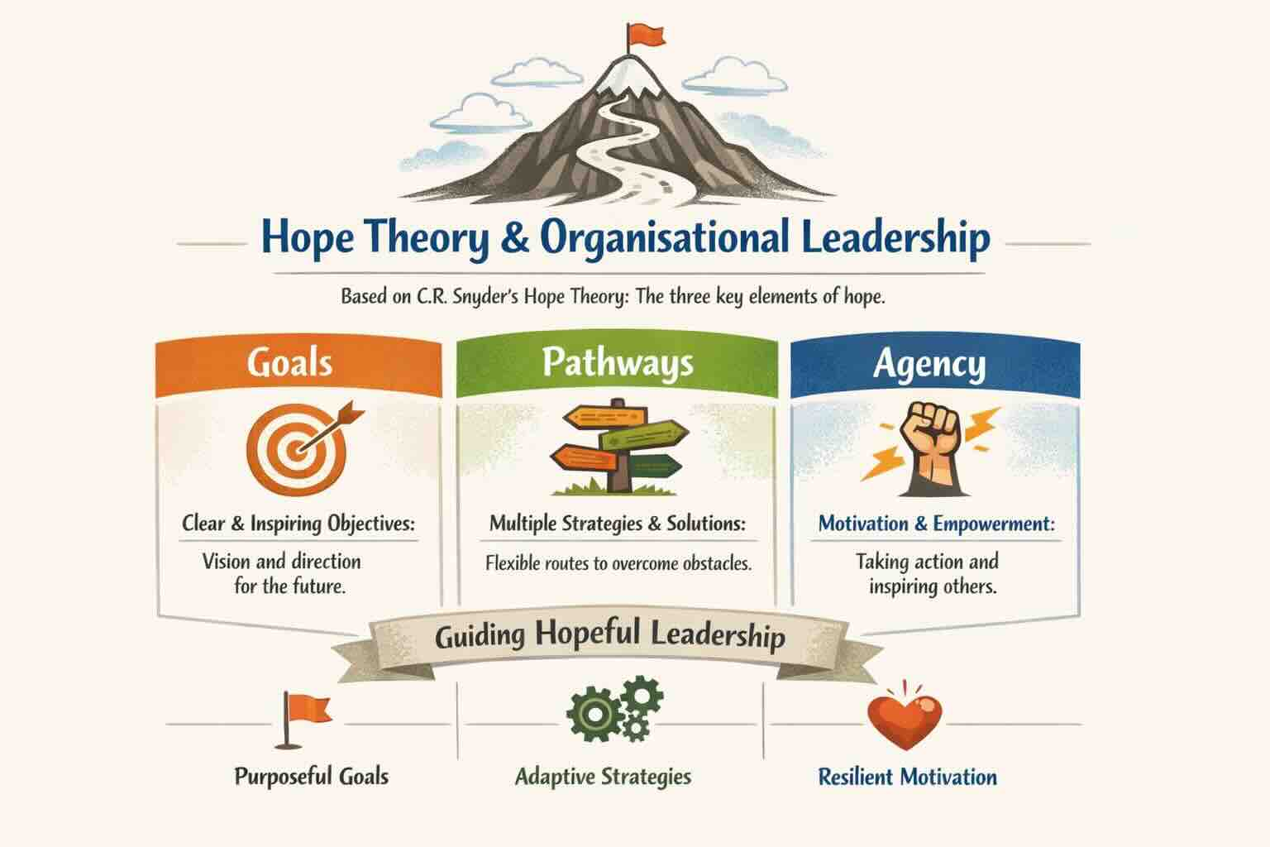

From an organizational perspective, Hope Theory has important implications for well-being, performance, and ethical leadership. Research consistently connects hope with greater engagement, improved problem-solving, and reduced burnout. Leaders who intentionally foster hope help protect their organizations against cynicism and despair, especially during times of transition or crisis. Instead of denying challenges, hope-based leaders acknowledge reality honestly while refusing to let obstacles determine the future.
In summary, Hope Theory reframes leadership as the work of nurturing purposeful goals, achievable pathways, and sustained agency—both in oneself and in others. For organizational leaders, hope is not a mere virtue but a strategic and ethical asset: it energizes vision, enhances resilience, and empowers communities to progress together with courage and purpose.

