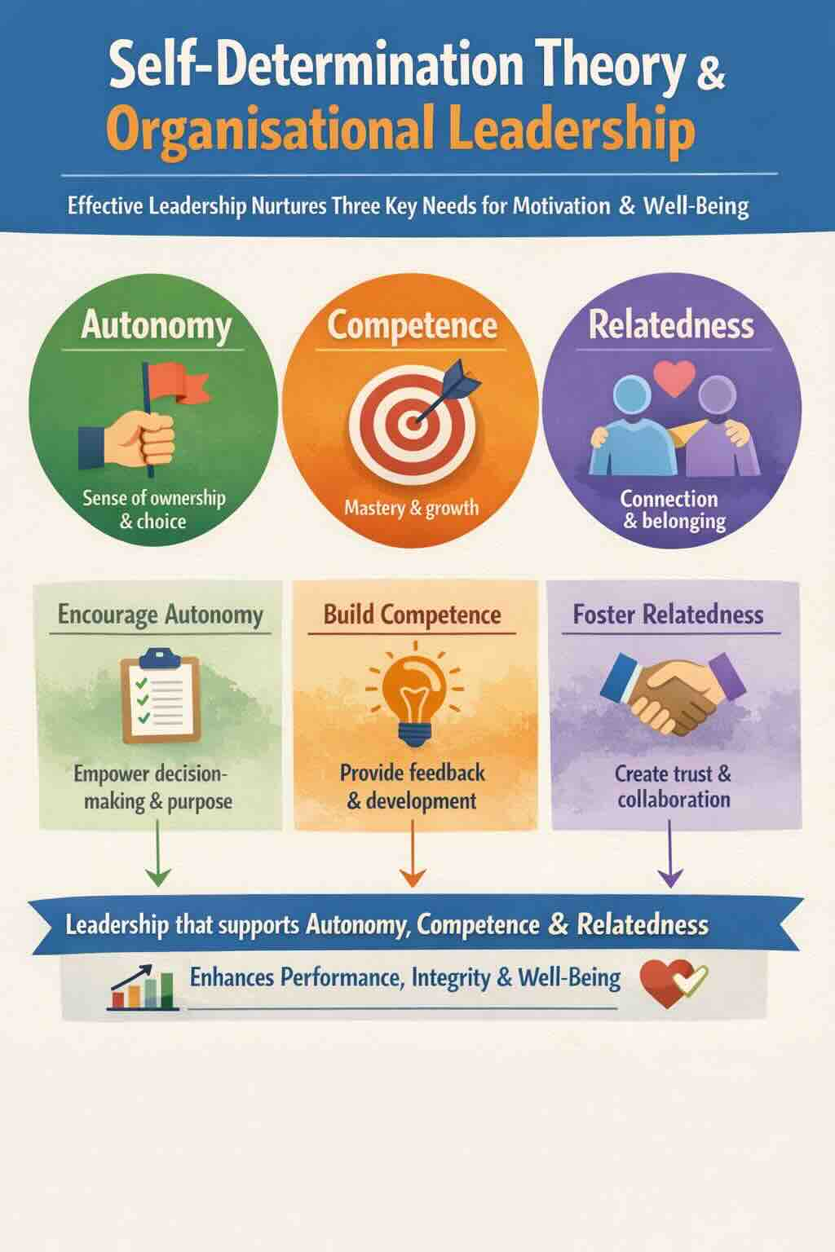
- Self-Determination Theory and Organizational Leadership
Self-Determination Theory (SDT), developed by Edward Deci and Richard Ryan, provides a strong framework for understanding effective organizational leadership. At its core, SDT suggests that people thrive and stay motivated when three basic psychological needs are met: (1) autonomy, (2) competence, and (3) relatedness. Leadership that respects these needs encourages not only better performance but also increased well-being, ethical integrity, and long-term dedication.
When leaders encourage the autonomy of the people in their organisations, it does not indicate a lack of structure or direction. Instead, it involves creating environments where individuals feel a sense of ownership and meaningful choice in how they perform their work. Leaders who explain the purpose behind decisions, invite participation, and trust others to make judgment calls foster intrinsic motivation rather than just compliance. This approach enhances creativity and resilience, especially in complex or uncertain situations.
Competence is the process of developing greater mastery and effectiveness. Organizational leaders support competence by setting clear expectations, giving constructive feedback, and investing in learning and development. When leaders view challenges as opportunities for growth rather than threats, they help people engage more fully and confidently with their responsibilities.
Relatedness emphasizes the relational aspect of leadership. People are more motivated when they feel respected, valued, and connected to others. Leaders who show empathy, listen carefully, and build trust foster cultures where collaboration and shared purpose thrive. In faith-based and value-driven organizations, this sense of belonging often becomes a key part of the mission.
Viewed through the lens of SDT, leadership is less about control and more about nurturing. By focusing on autonomy, competence, and relatedness, leaders create environments where individuals naturally internalize organizational goals and contribute with integrity, energy, and hope.
Scripture
“To each is given the manifestation of the Spirit for the common good” (1 Corinthians 12:7).
This verse affirms personal agency, gifted competence, and communal belonging, echoing the core insights of Self-Determination Theory.
What I ask God for
Gracious God, help me to lead and serve in ways that honor freedom, nurture gifts, and strengthen the bonds that unite us for the common good.
Questions to contemplate
- Where in my leadership do I genuinely support autonomy, and where might I rely too heavily on control or compliance?
- How am I intentionally fostering growth and confidence in those I lead, especially through challenging times or experiences of failure?
- What practices could deepen trust and belonging within our organization so that our shared mission is freely embraced?
Resource
McAnally, K., and M. S. Hagger. “Self-Determination Theory and Workplace Outcomes: A Conceptual Review and Future Research Directions.” Behavioral Sciences 14, No. 6 (2024): 428.

