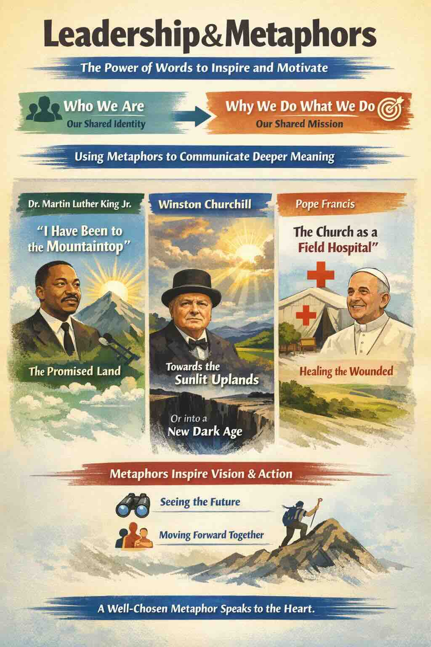
- Leadership and Metaphors
Central to a leader’s role is helping the organization focus on its foundational narrative, why it exists, and its goals and objectives. The way that a leader does this it by talking to staff about “Who we are” (their shared identity) and “Why we do what we do” (their shared mission). Such focusing is immensely helped by an adept use of metaphor. By using metaphors, leaders can communicate at a deeper, more symbolic, and more feeling level. Leaders use metaphors to help people to visualize the future and motivate action toward it. Here are some well-known examples.
Dr Martin Luther King Jr gave a speech on 3 April 1968, in Memphis. This is the final paragraph:
“Well, I don’t know what will happen now. We’ve got some difficult days ahead. But it really doesn’t matter with me now, because I’ve been to the mountaintop. And I don’t mind. Like anybody, I would like to live a long life. Longevity has its place. But I’m not concerned about that now. I just want to do God’s will. And He’s allowed me to go up to the mountain. And I’ve looked over. And I’ve seen the Promised Land. I may not get there with you. But I want you to know tonight, that we, as a people, will get to the Promised Land! And so I’m happy, tonight. I’m not worried about anything. I’m not fearing any man! Mine eyes have seen the glory of the coming of the Lord!”
Winston Churchill gave this speech to the House of Commons on 18 June 1940:
“What General Weygand called the Battle of France is over. I expect that the Battle of Britain is about to begin. Upon this battle depends the survival of Christian civilization. Upon it depends our own British life, and the long continuity of our institutions and our Empire. The whole fury and might of the enemy must very soon be turned on us. Hitler knows that he will have to break us in this island or lose the war. If we can stand up to him, all Europe may be free, and the life of the world may move forward into broad, sunlit uplands. But if we fail, then the whole world, including the United States, including all that we have known and cared for, will sink into the abyss of a new Dark Age made more sinister, and perhaps more protracted, by the lights of perverted science. Let us therefore brace ourselves to our duties, and so bear ourselves, that if the British Empire and its Commonwealth last for a thousand years, men will still say, ‘This was their finest hour.’”
Pope Francis said in an interview with Antonio Spadaro SJ in 2013:
“The thing the church needs most today is the ability to heal wounds and to warm the hearts of the faithful; it needs nearness, proximity. I see the church as a field hospital after battle. It is useless to ask a seriously injured person if he has high cholesterol and about the level of his blood sugars! You have to heal his wounds. Then we can talk about everything else. Heal the wounds, heal the wounds. ... And you have to start from the ground up.”
A metaphor can be defined as “a figure of speech in which a term or phrase is applied to something to which it is not literally applicable.” A metaphor transfers the meaning from one situation to another. “The Promised Land” was the metaphor used by Martin Luther King Jnr. for the freedom from ongoing political and social oppression of black people in the United States. King was fighting to “redeem the soul of America” by seeking equality of blacks before the law, integration, and voting rights for all. Just as Moses saw the Promised Land but did not enter, King hinted that he might face a similar fate. The very next morning, he was shot dead.
Churchill’s “broad, sunlit uplands” was his vision of the world that would exist if World War II was won. The “abyss of a new Dark Age” was his metaphor for the world that would exist if the Allies were not victorious in World War II. A “field hospital after battle” was Pope Francis’ metaphor for a healing and warm church. Metaphors can provide an evocative shorthand for challenging issues.

